|  |  |
| --- | --- |
|  | Abstract  Instant first task  13/3/2023  Eman Abdelkader Mohamed |

**Subtask (1)**

**Ai solutions without data: -** [AI without Data | Thoughtworks](https://www.thoughtworks.com/insights/blog/machine-learning-and-ai/ai-without-data)

If we have no data, we devise a plan to curate a data set in parallel with model and product development. This could mean developing a UI that allows users to label data as part of their (improved) workflow, forming one of many [active learning loops](https://www.thoughtworks.com/en-au/insights/blog/machine-learning-and-ai/active-learning-loops). It could also mean selecting an approach such as [reinforcement learning](https://www.thoughtworks.com/insights/blog/machine-learning-and-ai/reinforcement-learning-as-explainable-ai), that solves the “cold start” problem of no historical data by learning through [experimentation](https://thenextweb.com/news/how-this-company-leveraged-ai-to-become-the-netflix-of-finland). If it’s too costly to acquire data by either of these means, we may still explore [generated](https://www.fourkind.com/work/mackmyra) options through [simulation](https://www.thoughtworks.com/en-au/insights/blog/data-science-and-analytics/synthetic-data), paired with [optimisation](https://www.thoughtworks.com/en-au/insights/blog/data-science-and-analytics/operations-research) techniques.

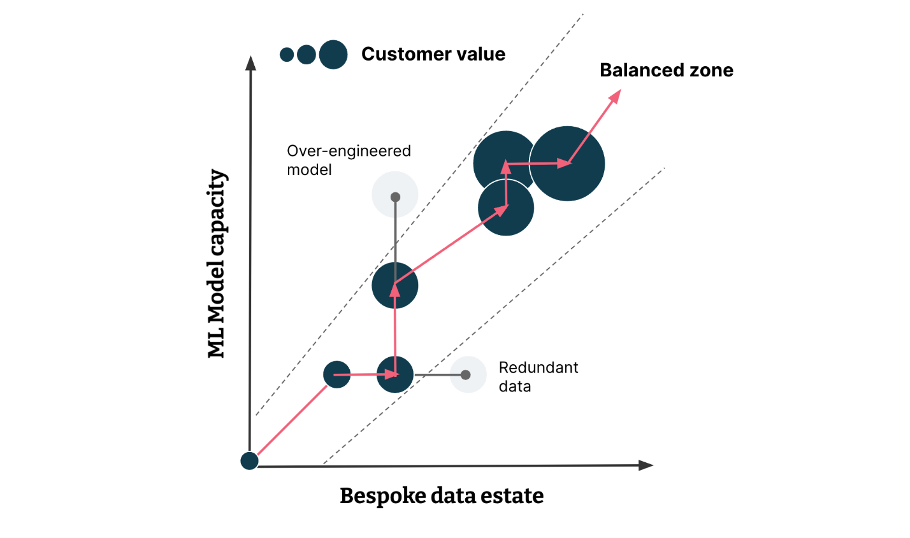

If we have unlabelled, unstructured, adjacent or historically incompatible data we can use techniques like transfer learning and [representation learning](https://www.youtube.com/watch?v=x0uI9l4nbqg) to bootstrap more performant models and create flexible data products that can be rapidly adapted to novel situations, when new data becomes available. If we have only a small data set or noisy labels, we can amplify the training signal with [weak labelling](https://www.thoughtworks.com/en-au/insights/blog/data-science-and-analytics/weak-labeling) based on features inherent in the data, or by providing human annotators with data programming tools to cheaply create many weak hints.

Beyond recognised issues of bias, the COVID-19 pandemic demonstrates that historical labelled data can be rendered obsolete with [extreme rapidity](https://www.thoughtworks.com/en-au/insights/blog/data-driven-responses-new-patterns-customer-behaviour). Whatever your approach to AI with data, you also need to be thinking about doing AI without data, and how to [rapidly validate](https://www.thoughtworks.com/en-au/insights/blog/agile-engineering-practices/slicing-data-stories) and [iterate](https://www.thoughtworks.com/en-au/insights/blog/machine-learning-and-ai/sensible-defaults-cd4ml) solutions in real [business processes](https://www.thoughtworks.com/en-au/clients/nimble) or [customer experiences](https://www.thoughtworks.com/en-au/clients/arkose-labs). If this sounds interesting, please get in touch to learn more.

*Disclaimer: The statements and opinions expressed in this article are those of the author(s) and do not necessarily reflect the positions of Thoughtworks.*

**Subtask (2)**

**List Of Ai Companies: -**

**Amazon web services**

A leader in cloud computing, [Amazon Web Services (AWS)](https://aws.amazon.com/) offers both consumer and business-oriented AI products and services, and many of its professional AI services build on the AI services available in consumer products.

Its Amazon Echo brings AI into the home with Alexa. For [AWS](https://aimagazine.com/machine-learning/aws-expands-partnerships-meta-aurora-and-discovery), the company’s primary AI services include Lex, a business version of Alexa; Polly, which turns text into speech; and Recognition, an image recognition service. The company also conducts an AI innovation contest with prizes up to $500,000.

**IBM**

[IBM](https://www.ibm.com/uk-en) has been a leader in the field of artificial intelligence since the 1950s. [The company](https://aimagazine.com/ai-applications/ibms-new-ai-driven-software-environmental-intelligence)’s core offering is [IBM Watson,](https://aimagazine.com/ai-applications/how-ibm-watson-became-popular-ai-tool-business) an AI-based cognitive service, AI software as a service, and scale-out systems designed for delivering cloud-based analytics and AI services. IBM’s portfolio of business-ready tools, applications and solutions, are designed to reduce the costs and hurdles of AI adoption while optimizing outcomes and responsible use of AI. 70% of global banking institutions use Watson and 13 of the top 14 systems integrators use Watson.

**C3.ai**

[C3.ai](https://c3.ai/) is the world’s leading provider of Enterprise AI. Founded in 2009, the company aims to support and accelerate digital transformation with its proven C3 AI Suite, an end-to-end platform for developing, deploying and operating large-scale AI applications.

The [C3 AI](https://aimagazine.com/ai-strategy/c3-ai-ai-company-partnership-google) Suite provides comprehensive services to build enterprise-scale AI applications more efficiently and cost-effectively than alternative approaches. It also supports the value chain in any industry with prebuilt, configurable, high-value AI applications for reliability, fraud detection, sensor network health, supply network optimisation, energy management, anti-money laundering, and customer engagement.

**DeepMind**

[DeepMind](https://www.deepmind.com/) is an AI research and development company that operates as a subsidiary of Alphabet. It also develops AI for positive outcomes in the healthcare sector. British academics Demis Hassabis, Shane Legg, and Mustafa Suleyman founded the company in 2010. The startup trained its AI algorithms on old games from the ‘70s and ‘80s to make it incrementally more intelligent over time. Google acquired DeepMind for $500 million in 2014.

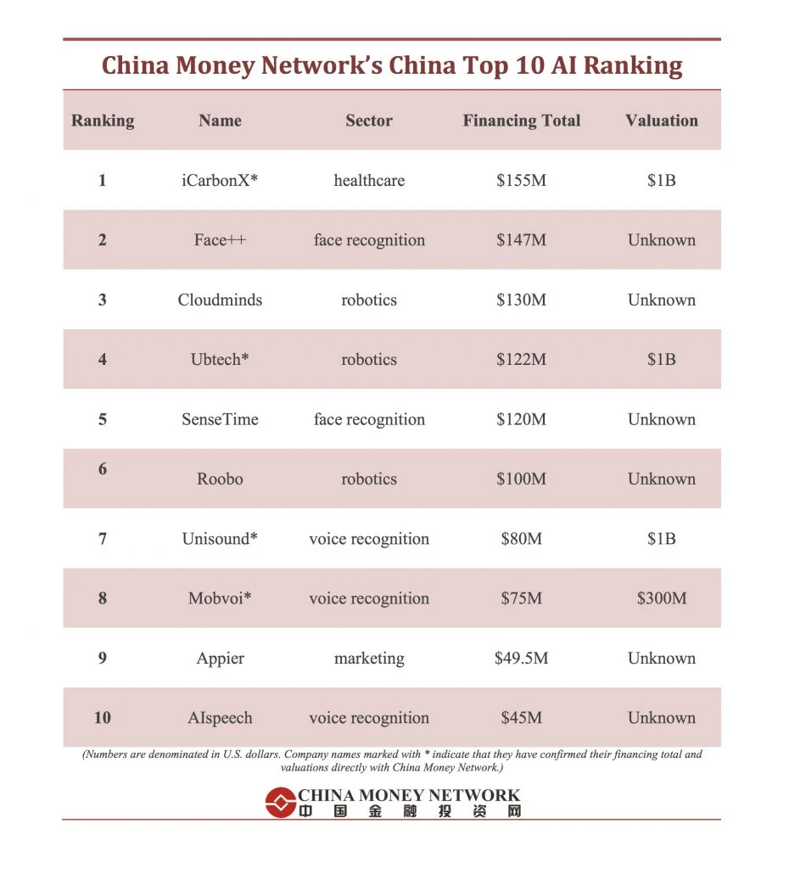

Search resources:

[68 Artificial Intelligence (AI) Companies to Know | Built In](https://builtin.com/artificial-intelligence/ai-companies-roundup)

[Top 10 artificial intelligence companies in 2022 | AI Magazine](https://aimagazine.com/top10/top-10-artificial-intelligence-companies-in-2022)

**Subtask (3)**

**Interpreter & Compiler: -**

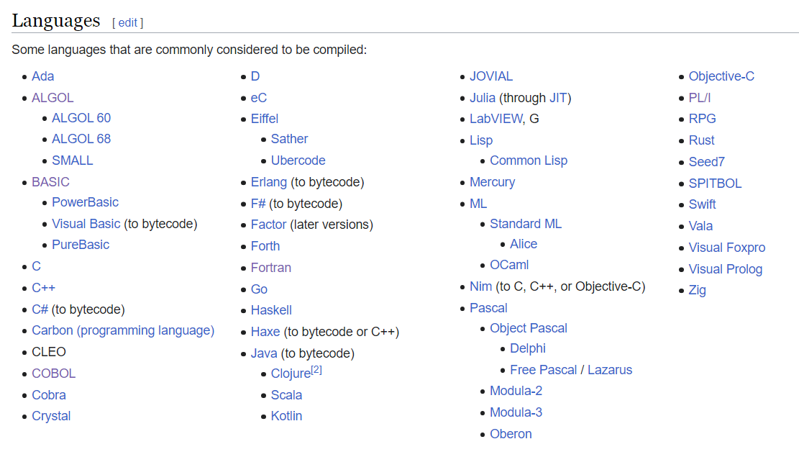A **compiled language** is   
a [programming language](https://en.wikipedia.org/wiki/Programming_language) whose [implementations](https://en.wikipedia.org/wiki/Programming_language_implementation) are typically [compilers](https://en.wikipedia.org/wiki/Compiler) (translators that generate [machine code](https://en.wikipedia.org/wiki/Machine_code) from [source code](https://en.wikipedia.org/wiki/Source_code)), and not [interpreters](https://en.wikipedia.org/wiki/Interpreter_(computing)) (step-by-step executors of [source code](https://en.wikipedia.org/wiki/Source_code), where no pre-runtime translation takes place).

**Interpreted languages** :  
are programming languages for which instructions are not precompiled for the target machine in a machine-readable form. Rather, these languages are assisted by an interpreter. An **interpreter** is a program that translates high-level, human-readable source code into low-level, machine-readable target code line by line *while the interpreted program is being executed*.

Interpreting the language is **less efficient** because the interpreter must be present for the entire process, but these languages are also **highly adaptable**.

Some examples of interpreted languages include:

* Python
* JavaScript
* PHP
* MATLAB
* Perl
* Ruby

Search resources:

* Educative

[Compiled vs interpreted language: Basics for beginning devs (educative.io)](https://www.educative.io/blog/compiled-vs-interpreted-language)

**Subtask (4)**

**Open-Source & Not Open-Source Languages: -**

## Top Open-Source Programming Languages

There are many different types of open-source programming languages based on the type of project being built. When it comes to app development, there are some alternatives that have established themselves as the de facto standard.

These are some of the best open-source programming languages:

### **Ruby on Rails (RoR)**

This is actually a [web development framework](https://www.koombea.com/blog/a-guide-to-web-development-frameworks-in-2021/) and a very popular one, to say the least. It is used for a number of different projects, and it is a favorite for developers thanks to its easy-to-use syntax based on the open-source and object-oriented Ruby language. It serves both back-end and front-end purposes. Thanks to its code structure, RoR can be used in projects that require scaling.

### **Python**

Developed in the late 1980s, [Python](https://www.koombea.com/blog/pros-and-cons-of-using-python-for-web-development/) is an object-oriented and high-level programming language. Its syntax is very friendly, making it a great choice for projects that need to be done in a short amount of time. Because of this, it is ideal for building powerful [Minimum Viable Products](https://www.koombea.com/services/mvp/). It is a very popular alternative among data scientists, but it can also be used for other purposes like web development and Machine Learning, thanks to its numerous libraries.

### **Swift**

This programming language is replacing Objective-C, the once-famous Apple language. [Swift](https://swift.org/about/#swiftorg-and-open-source) has become the standard for [iOS app development](http://www.koombea.com/services/ios-app-development), as it can help developers build powerful User Experiences in an easy way. This language is constantly evolving, bringing new innovations for developers with each iteration. It is a very stable language with a great performance.

### **JavaScript**

This is another high-level language that has gained a lot of attention and popularity in recent years, especially because of its web-friendly capabilities. It is becoming an industry standard for many projects in different industries. Mozilla Firefox and Thunderbird are just some of the better-known software projects developed with JavaScript.

### **Java**

This is another object-oriented programming language. It is the language on which Android is built, although it is being replaced by other languages like Rust and Kotlin. Java’s virtual machine is one of its main features, as it allows different languages to be interpreted across any device, making it an ideal [cross-platform app development](https://www.koombea.com/services/cross-platform/) alternative.

### **Kotlin**

Like Java, Kotlin is an open-source language that runs on the Java virtual machine. It has become a popular alternative for [Android app development](http://www.koombea.com/services/android-app-development). Unlike Java, Kotlin’s syntax helps developers save valuable time writing code. It is also object-oriented.

* Scala
* Pony
* Perl
* Haskell
* Elixir
* Erlang
* Kotlin
* Rails
* Python
* Rust
* Java
* Java script
* SQL
* R
* C
* C++
* Ruby
* Typescript
* Swift
* Shell
* Php
* C#

**Not Open-Source Languages**

Search resources:

* Google
* tridens

[Top 20 Programming Languages for Open-Source projects in 2022 (tridenstechnology.com)](https://tridenstechnology.com/top-programming-languages-for-open-source-projects/)

* koombea

[Open-Source Programming Languages Explained (koombea.com)](https://www.koombea.com/blog/open-source-programming-languages-explained/)

* Makeuseof

[Open-Source vs. Closed-Source Software: What's the Difference? (makeuseof.com)](https://www.makeuseof.com/open-source-vs-closed-source-software-difference/)

**Subtask (5)**

**R Language: -**

**Is:**

R is a programming language and analysis tool

**Developed**:

**In** 1993 **by** Robert Gentleman and Ross Ihaka **at** the University of Auckland

**Features**:

* Free and open source
* Support OOP
* General Public License
* It has interoperability across platforms which means it has distributions running on Windows, Linux and Mac ... R language code can easily be converted from one platform to another.
* It uses an interpreter instead of compiler.
* R is an interpreted language, which means that users access its functions through a command-line interpreter.
* R is not a general-purpose programming language. Instead, it’s considered a**domain-specific language** (DSL), meaning its functions and use are designed for a specific area of use or domain.
* R is specifically used for statistical analysis and data visualization
* R Advantage

- **Third-party libraries and packages**: The massive community behind R is constantly releasing new packages that improve and extend the language’s functionality.

**- Statistics**: R was designed specifically for statistical computing and analysis, and it’s the most popular programming language used in the field.

**- Interpreted**: As an interpreted language, you can run R code without using a compiler.

**- Platform independent**: R is a cross-platform programming language, so it can run on most operating systems.

* R Disadvantage
* **Complex syntax**: R has a steep learning curve, and it’s not well-suited to new developers.
* **Memory usage**: R provides few memory management features and stores data in physical memory, which can pose an issue when working with larger data sets.
* **Security**: R doesn’t have many security features, leaving it vulnerable to exploitation.

Search Resources:

- Google

- DataCamp

-CodeCademy

[What Is R Used For? Exploring The R Programming Language (codecademy.com)](https://www.codecademy.com/resources/blog/what-is-r-used-for/)

**Subtask (6)**

**Language Not Support OOP: -**

* Assembly “not sure”
* Algol “not sure”
* C
* Linq
* Lambdas

Search Resources:

* Quora   
  [Can an assembly language be considered as an object-based language? - Quora](https://www.quora.com/Can-an-assembly-language-be-considered-as-an-object-based-language)   
    
  [Is Algol object-oriented? - Quora](https://www.quora.com/Is-Algol-object-oriented)
* Stack overflow

[object - What languages aren't considered OOP languages - Stack Overflow](https://stackoverflow.com/questions/30487516/what-languages-arent-considered-oop-languages)